**ANALYSING HOUSING PRICES IN METRO POLITICION AREA IN INDIA**

**INTRODUCTION:**

**1.1 Over view**

The idea of development, the common features emerged in different point of the time is the development gap that emerged in the parts of the world and also among the various parts of country in a particular time. This disparity in development, like agriculture, industries, and some developments in India.one of the major development is the house developing in India. Keeping in the view the above fact of rapid urbanisation regional disparities, it is not unexpected that may lead to some sort of different regional housing prices, where housing and real estate are considered as major physical assets, leads to the differences in the dynamics price determination.

**1.2 Purpose**

Housing prices leads to the differences in the dynamics price determination.it means if there might shift the house prices from average, in the county, depending upon the economic status. For average housing prices in the poorer provinces might be lower than the national similarly, for richer states, the urban house prices, on average might be higher national average.

**PROLEM DEFINITION AND DESIGN THINKING**

**2.1** Empathy map

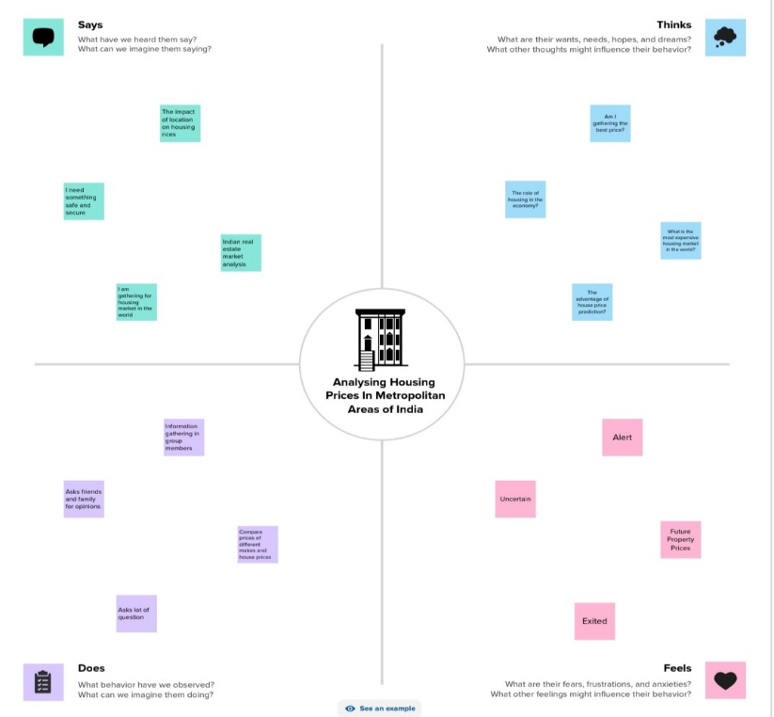

**2.2** Brain storming

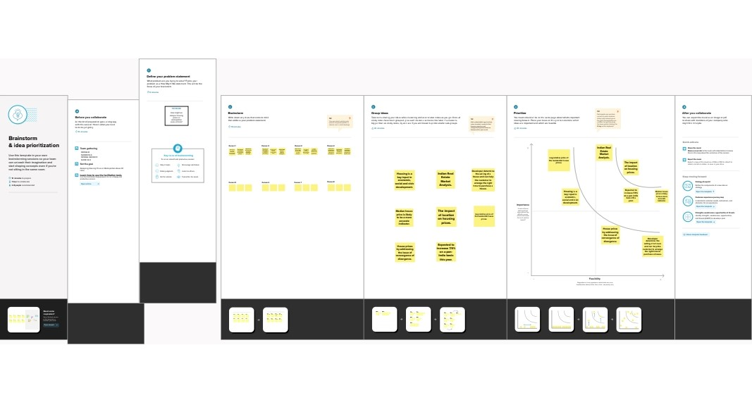

**RESULT**

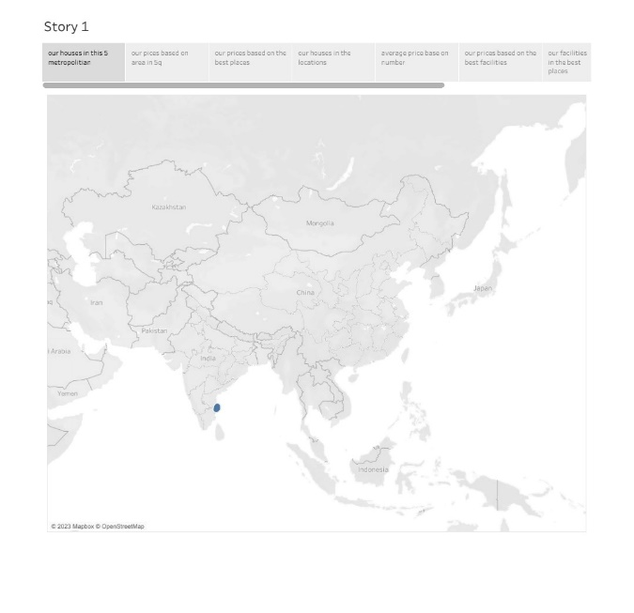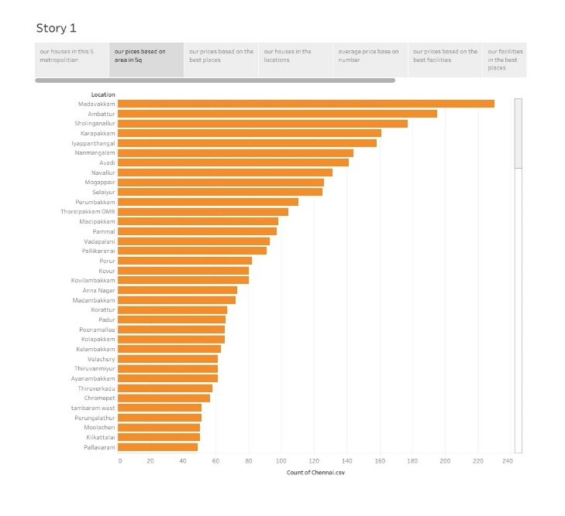

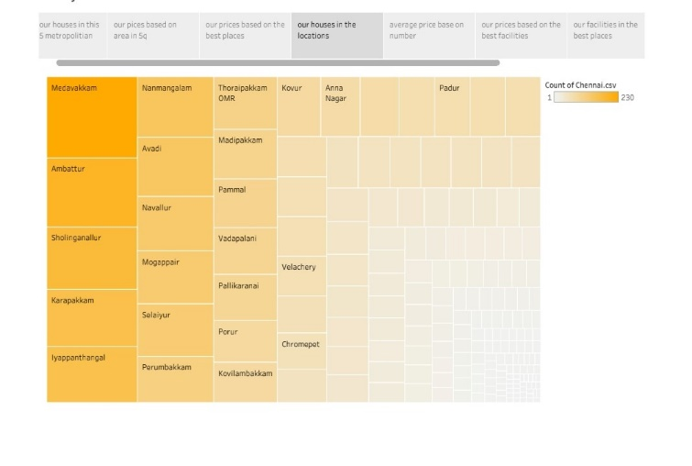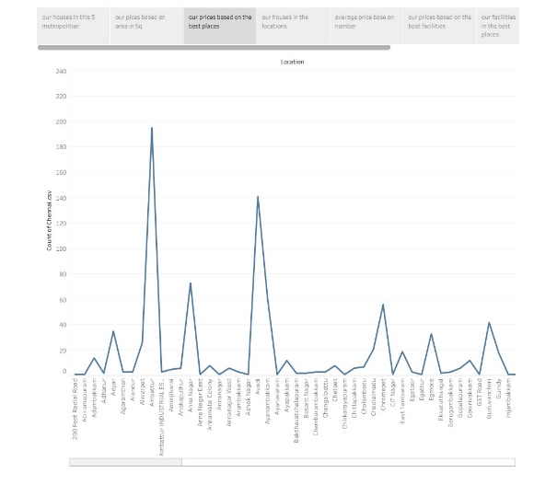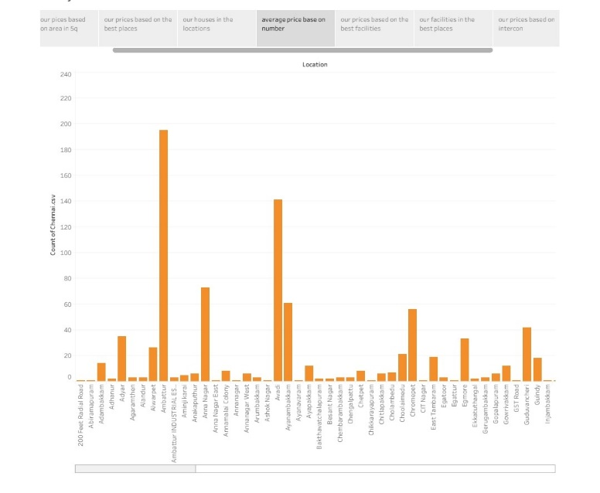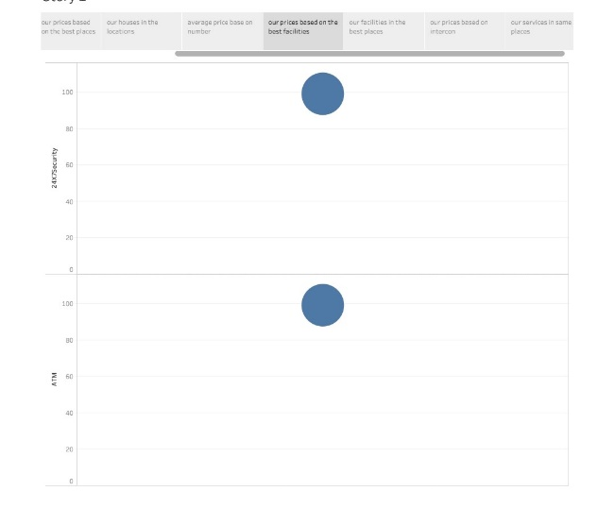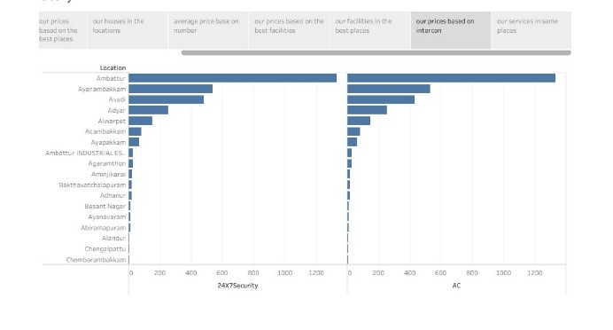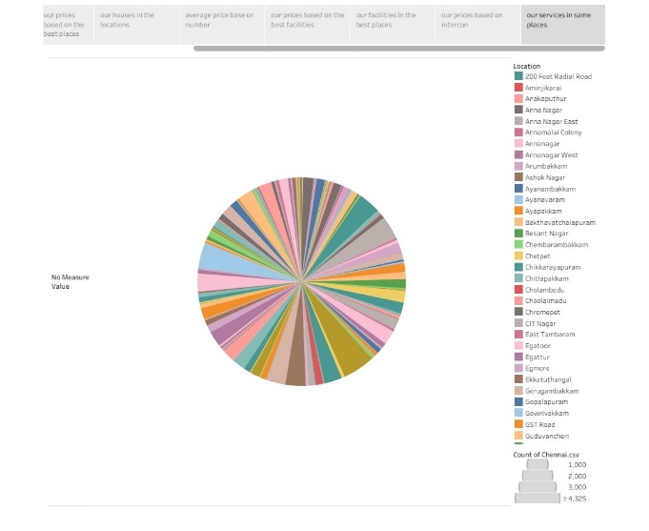

**ADVANTAGS AND DISADVANTAGES**

**Advantages:**

* Housing price prediction can help the developer determine the selling price of a house and can help the customer to arrange the right time to purchase a house.
* The consistently high probabilities of the relative house prices indicate that the series is consistently nonstationary and therefore diverges indefinitely in the long run.
* The lack of converges of the relative house prices simply implies that separate metro politician cities function as separate housing markets in their respective localities.
* In other words, the law of one price does not hold in Indian housing market case.

**Disadvantages:**

* Property prices in India are expected to increase 7.5% on a pan-India basic this year, fastest growth in five years, according to Reuters poll of property analysts.
* Average house prices were forecast to raise 6% next year and in 2024.

**APPLICATION**

Housing is a key input in economic, social, and civic development. Housing price help prediction can help the developer determine the selling price of a house and can help the customer to arrange the right time to purchase a house.

**CONCULUTION**

Prediction housing prices are expected to help people who plan buy a house so they can know the price range in the future, then they can plan their finance well.in addition , house price predictions are property investors to know the trend of housing prices in a certain location.

**FUTURE SCOPE**

Various reports suggest that the property market in India will exhibit a compound annual growth rate of 9.2% during the period between 2023and 2028.

* Heavy pressure of population.
* Unemployment and under employment.
* Capital deficiency.
* Under-developed economy.
* Increase in price.